Module 3: Networking
1.Successful creation of the custom Virtual Private Cloud (VPC) providing an isolated network environment for the assignment resources.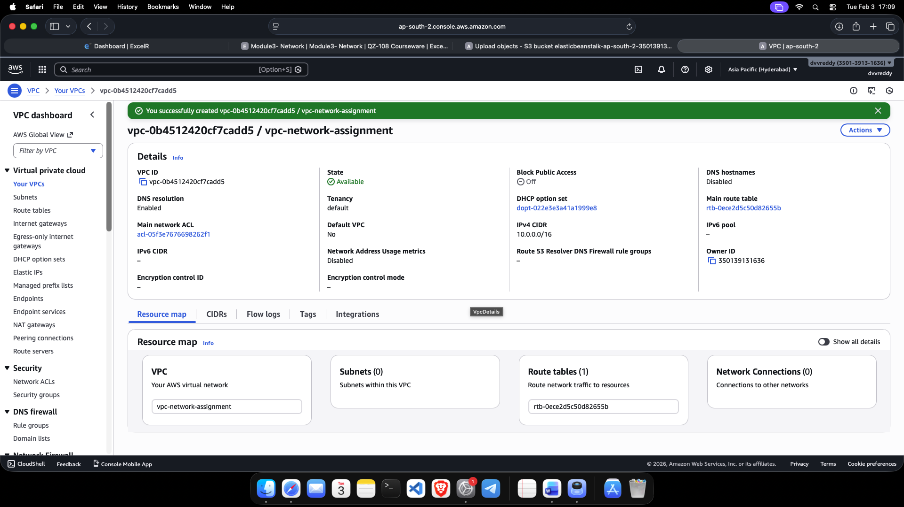
2.Configuration of an Internet Gateway (IGW) and attachment to the VPC to enable communication between the cloud resources and the internet.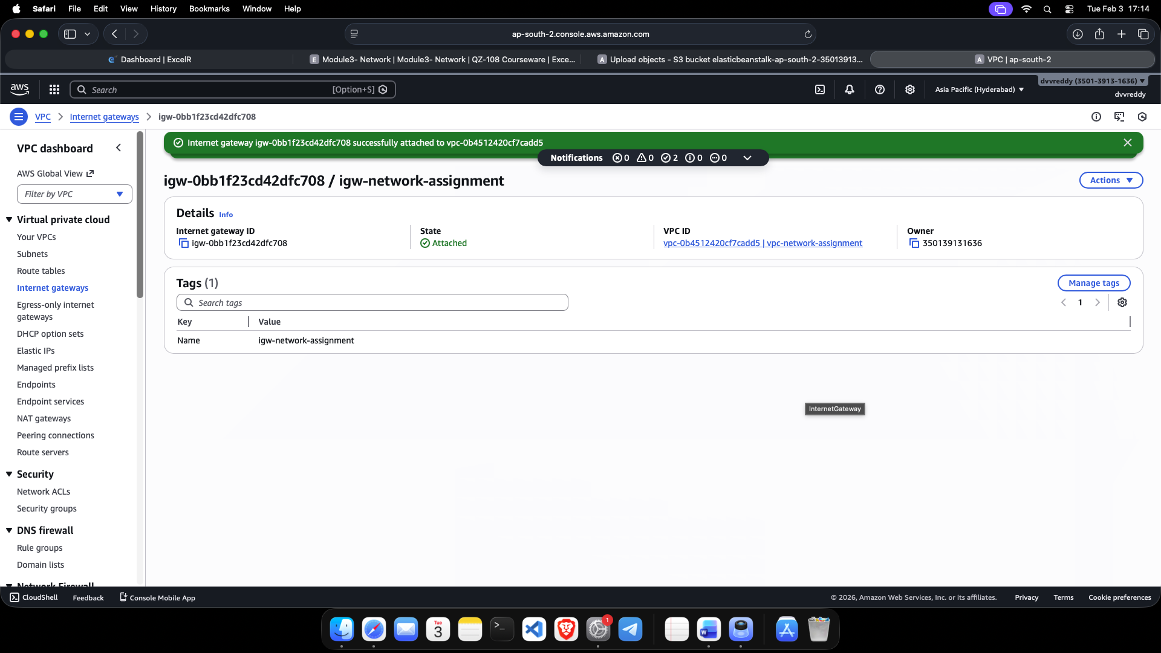
3.Configuration of two distinct subnets within the VPC and the update of the Route Table to direct outbound traffic through the Internet Gateway.

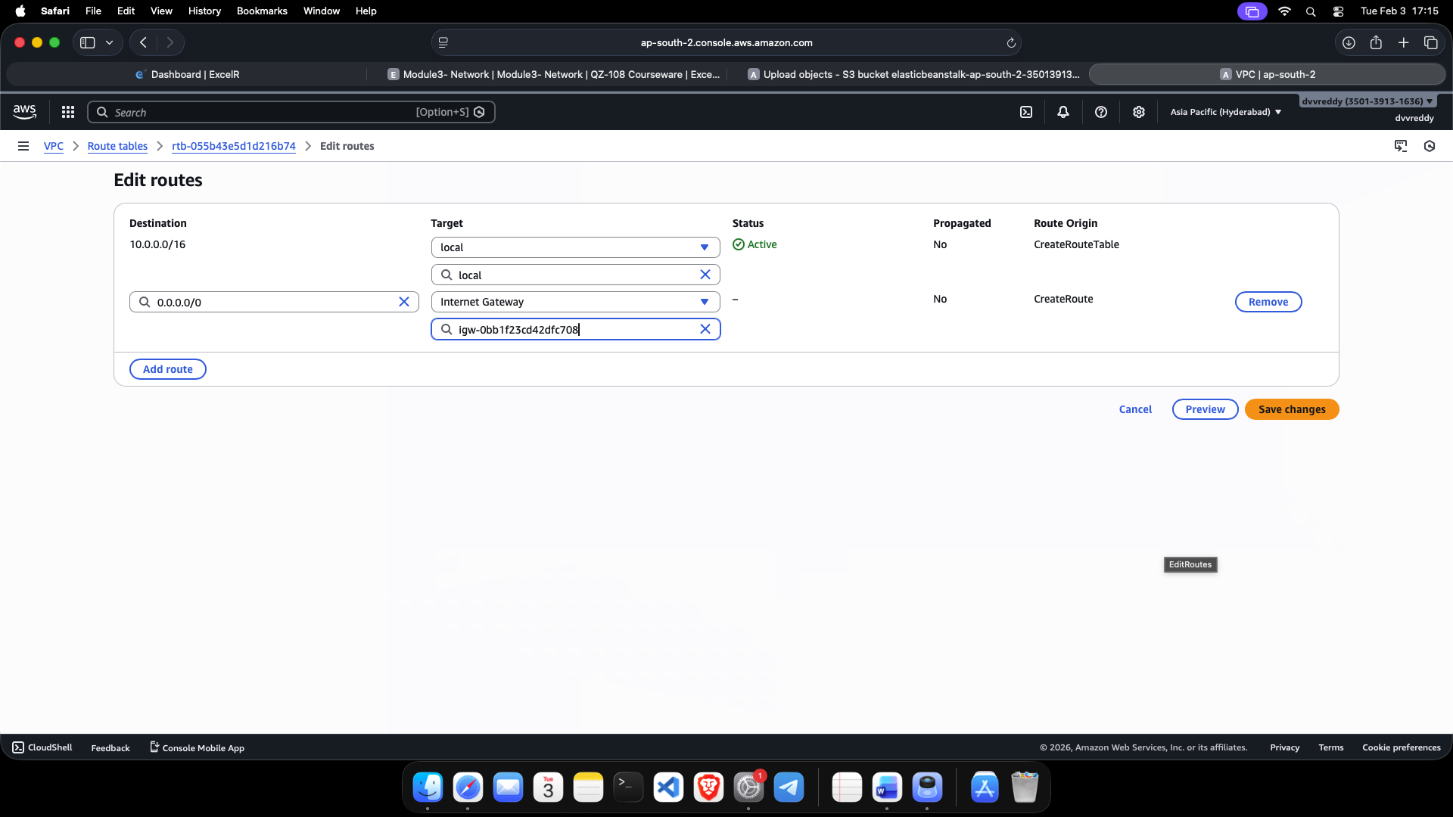
4.Deployment of two EC2 Linux instances, each positioned in a separate subnet to test inter-subnet connectivity.

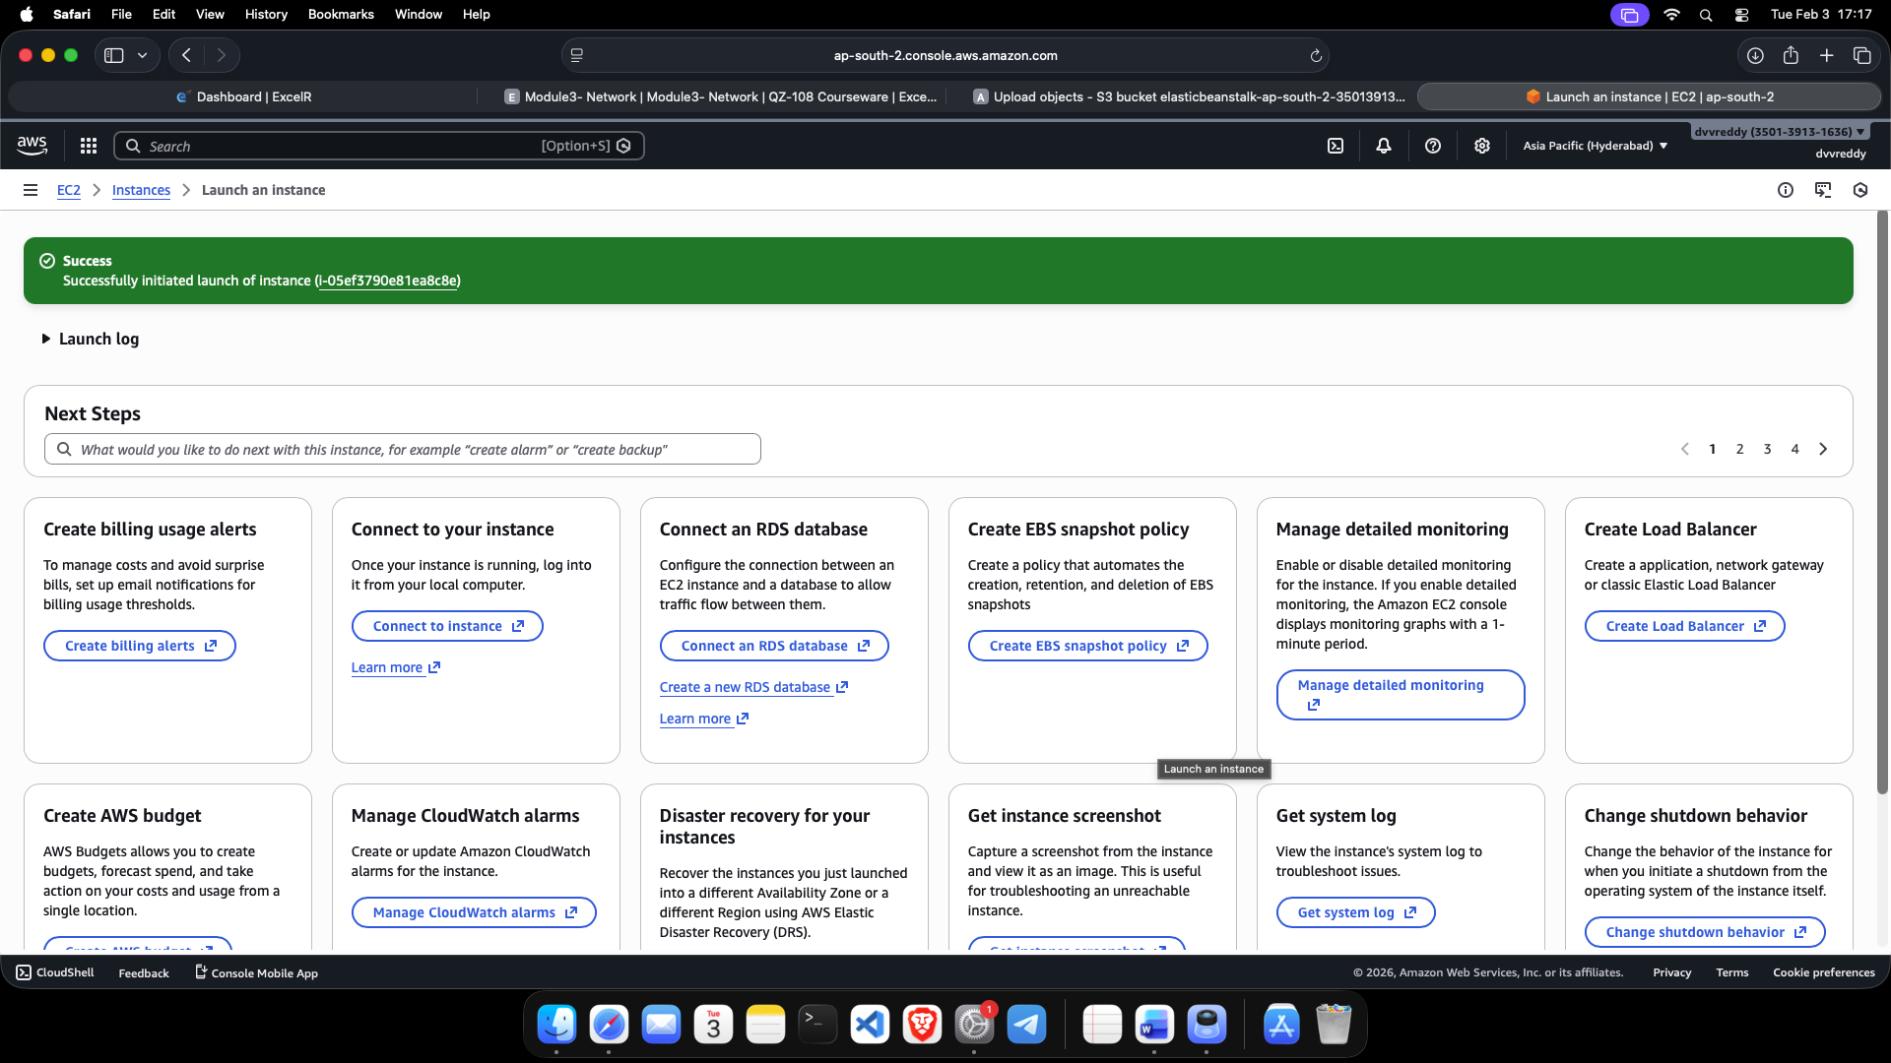
5.Verification of network connectivity using the ping command from Instance A to Instance B, confirming successful internal routing and security group configuration.
